Box-Cox test for the Nile River data suggests that a log transformation (power of 0)of the data would result in a normality distribution.

Box-Cox Power Transformation:

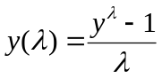 if 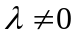 and 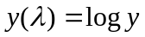 if 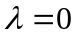

Box-Cox Transformation to Normality

Est.Power Std.Err. Wald(Power=0) Wald(Power=1)
-0.0676 0.4165 -0.1622 -2.5633

L.R. test, power = 0: 0.0263 df = 1 p = 0.8711
L.R. test, power = 1: 6.6113 df = 1 p = 0.0101

Normality tests for the original vs. log transformed Nile data

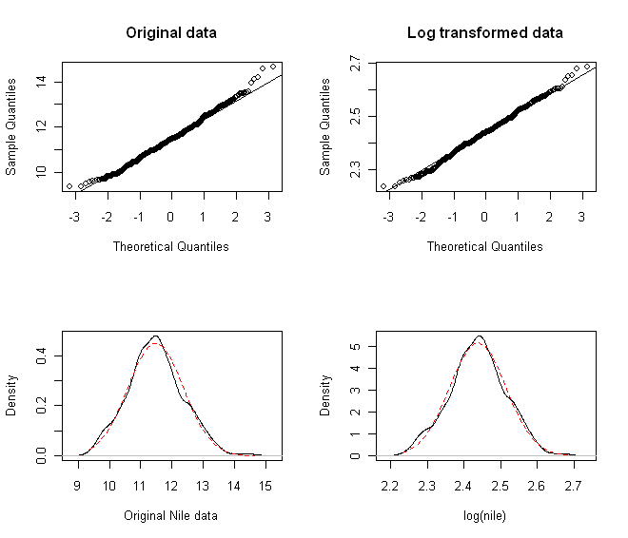

Original Nile data  One-sample Kolmogorov-Smirnov test  STATISTIC:  D: 1  P VALUE:  Alternative Two-Sided: < 2.2e-16  Alternative Less: < 2.2e-16  Alternative Greater: 1  Shapiro - Wilk Normality Test  STATISTIC:  W: 0.9933  P VALUE:  0.004614  Jarque - Bera Normalality Test  STATISTIC:  X-squared: 6.8061  P VALUE:  Asymptotic p Value: 0.03327  Anderson - Darling Normality Test  STATISTIC:  A: 0.9264  P VALUE:  0.01859  D'Agostino Normality Test  STATISTIC:  Chi2 | Omnibus: 6.9094  Z3 | Skewness: 2.5507  Z4 | Kurtosis: 0.6349  P VALUE:  Omnibus Test: 0.0316  Skewness Test: 0.01075  Kurtosis Test: 0.5255  Lilliefors (KS) Normality Test  STATISTIC:  D: 0.0439  P VALUE:  0.004084 | Log transformed Nile data  One-sample Kolmogorov-Smirnov test  STATISTIC:  D: 0.9873  P VALUE:  Alternative Two-Sided: < 2.2e-16  Alternative Less: < 2.2e-16  Alternative Greater: 0.9827  Shapiro - Wilk Normality Test  STATISTIC:  W: 0.9963  P VALUE:  0.1302  Jarque - Bera Normalality Test  STATISTIC:  X-squared: 0.1235  P VALUE:  Asymptotic p Value: 0.9401  Anderson - Darling Normality Test  STATISTIC:  A: 0.6247  P VALUE:  0.1034  D'Agostino Normality Test  STATISTIC:  Chi2 | Omnibus: 0.0616  Z3 | Skewness: 0.1621  Z4 | Kurtosis: -0.1879  P VALUE:  Omnibus Test: 0.9697  Skewness Test: 0.8713  Kurtosis Test: 0.851  Lilliefors (KS) Normality Test  STATISTIC:  D: 0.0371  P VALUE:  0.03039

